Productivity potentials and economics of Whole package demonstrations :

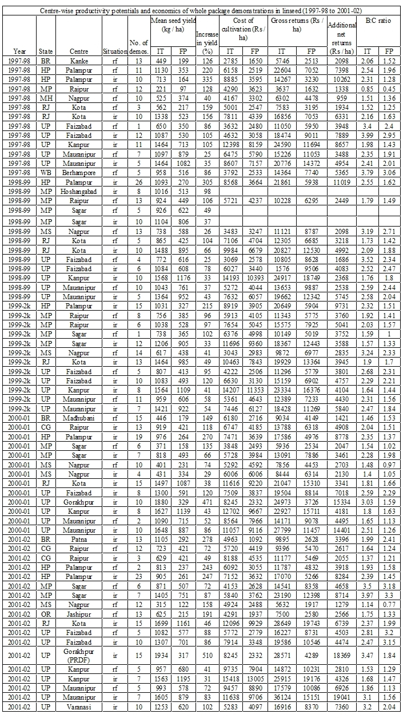
Productivity potentials and economics of Component technologies :

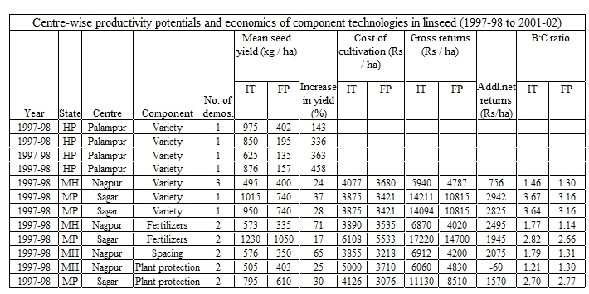

Productivity potentials and economics of Intercropping :



