Productivity potentials and economics of Whole package demonstrations:

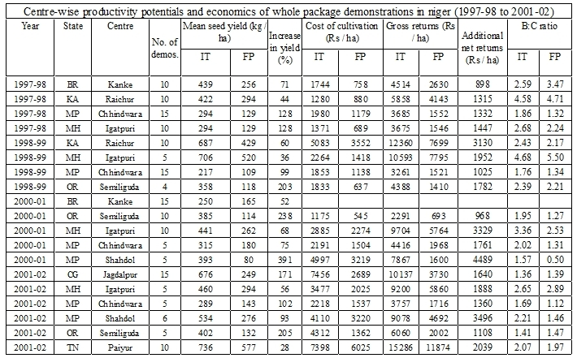

Productivity potentials and economics of Component technologies

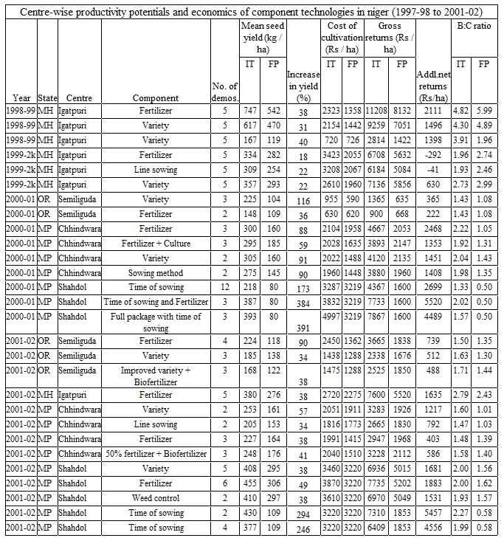

Productivity potentials and economics of Intercropping



