Productivity potentials and economics of whole package technologies

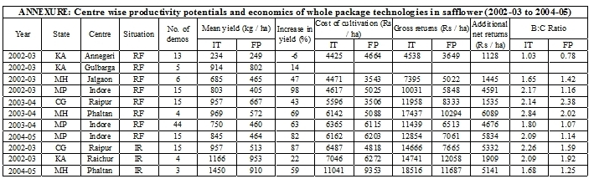

Productivity potentials of component technology



