Productivity potentials and economics of Whole package

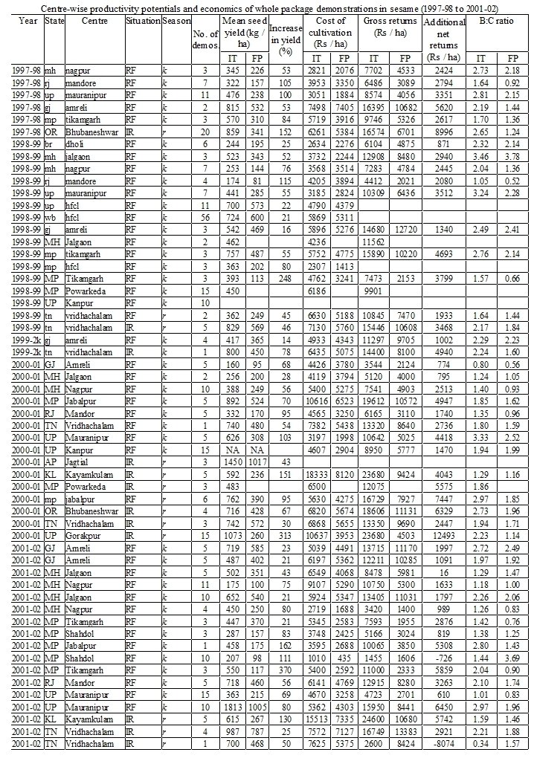

Productivity potentials and economics of Intercrops

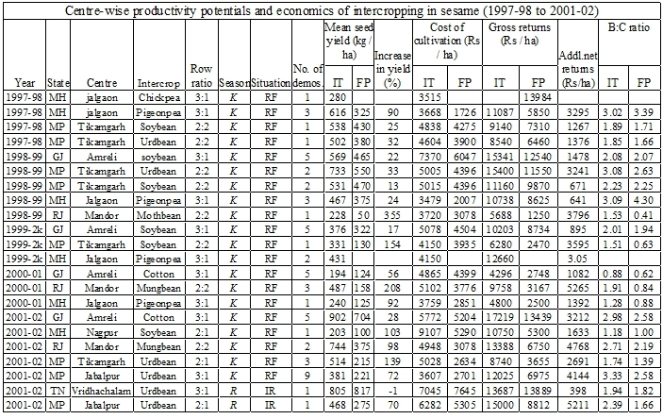

Productivity potentials and economics of Component technologies



