Productivity potentials and economics of Whole package demonstrations :

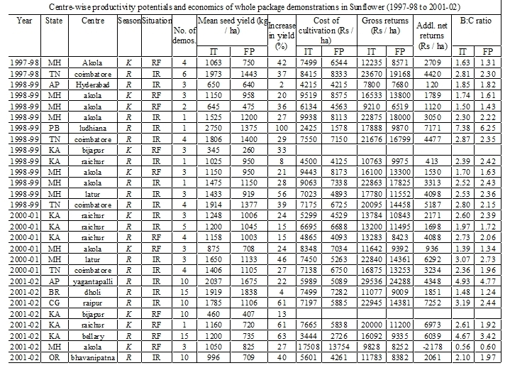

Productivity potentials and economics of Intercropping demonstrations :

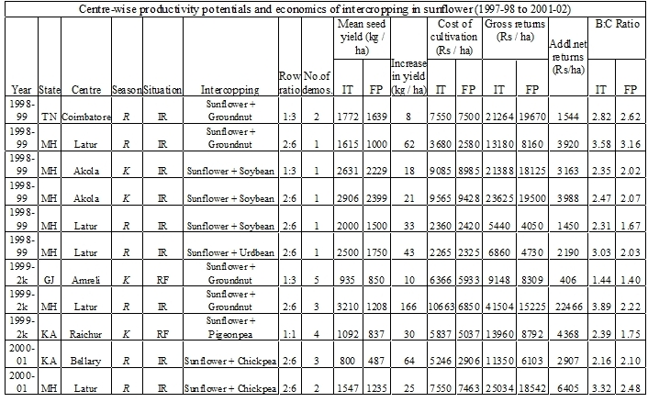

Productivity potentials and economics of Component technology demonstrations :



