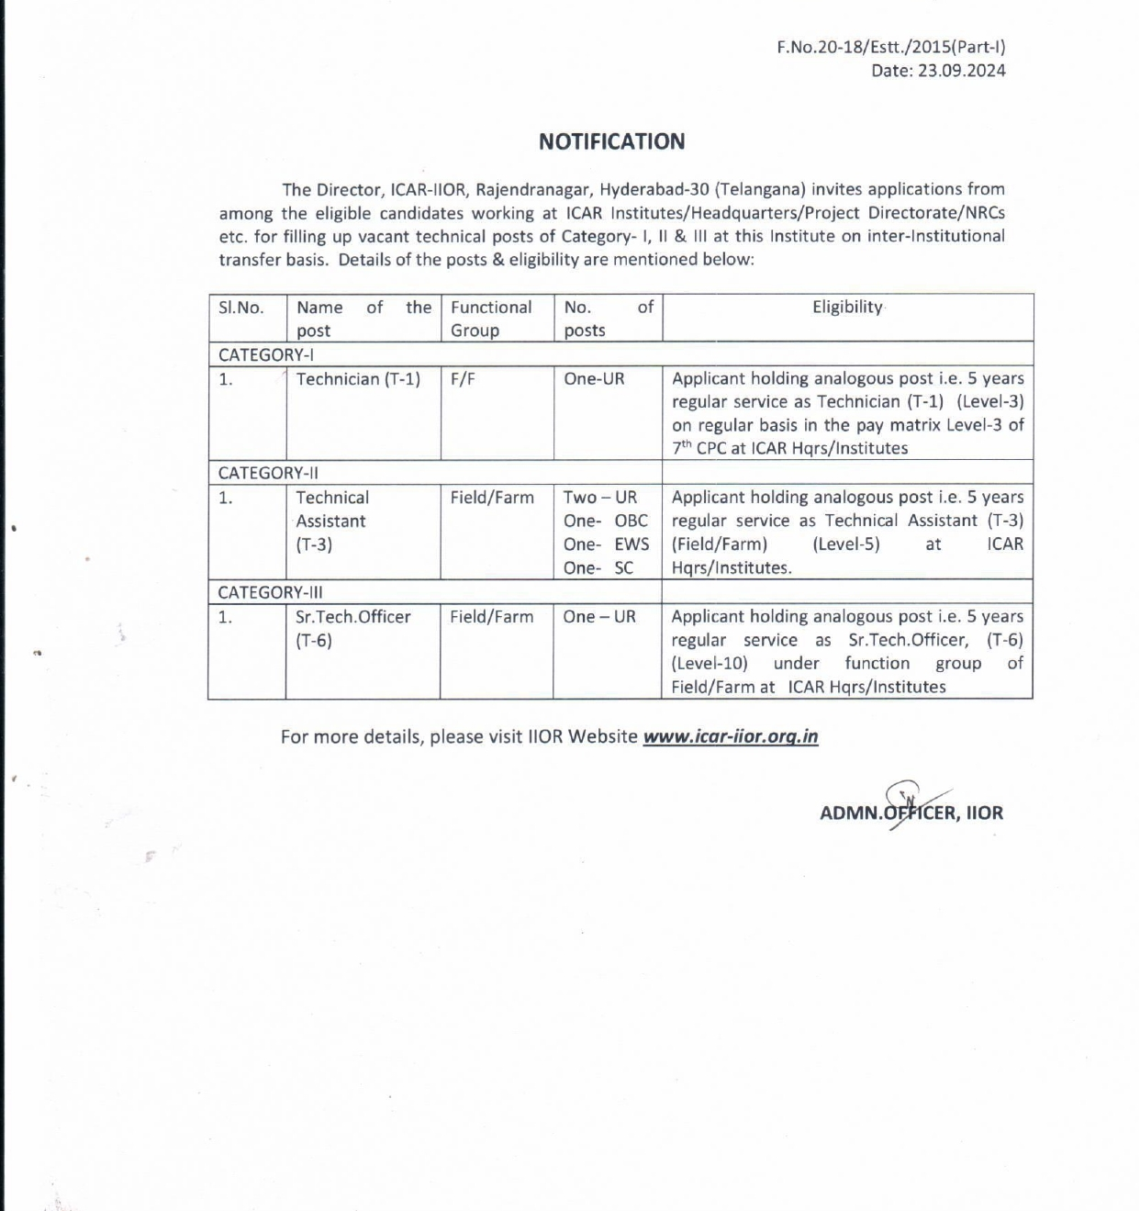

**APPLICATION FOR THE POST OF TECHNICIAN/ TECHNICAL ASSISANT(T-3)/SR. TECH.OFFICER (T-6) IN CATEGORY- I ,II & III AT ICAR-IIOR, RAJENDRANAGAR, HYDERABAD(TELANGANA)**

|  |  |  |
| --- | --- | --- |
| Sl .No. | Particulars to be fill |  |
| 1 | Name of applicant (in BLOCK letters) |  |
| 2 | Name of Institute where applicant is presently working |  |
| 3 | Date of appointment on regular basis in the Technical Assistant/ Hindi Assistant/Translator |  |
| 4 | Whether Permanent/Temporary |  |
| 5 | Date of Birth & Age |  |
| 6 | Education qualifications giving details of Examination passed from matriculation onwards |  |
| 7 | Whether SC/ST/OBC |  |
| 8 | Full postal/ correspondence address |  |
| 9 | Contact No. |  |
| 10 | Service particulars |  |

|  |  |  |  |  |  |  |
| --- | --- | --- | --- | --- | --- | --- |
| Name of inst. | Post held | Scale of pay | Period | | Nature of duty | Whether Adhoc or on regular basis |
|  | from | to |
|  |  |  |  |  |  |  |
|  |  |  |  |  |  |  |
|  |  |  |  |  |  |  |
|  |  |  |  |  |  |  |

|  |  |  |
| --- | --- | --- |
| 11 | Any other Information relevant to the service of the applicant |  |

I do hereby declare and certify that the information furnished is correct and true to the best of my knowledge and belief. In the event of any information found false or incorrect at any time before or after the selection, action may be taken against me and I shall abide by the decision of the Director, ICAR-IIOR, Hyderabad.

Place:

Date: Signature of Applicant

**Certificate to be furnished by the Head of Office**

Certified that particulars furnished above have been verified from the service book and found correct. Attested copies of last 5 years APARS are enclosed. It is also certified that application being forwarded by this Institute is in conformity with ICAR-IIOR Notification No. _________________________ dated ___________________ and that he/she fulfills all the requisite criteria as mentioned therein and the ICAR Guidelines regarding inter-intuitional transfer of such personnel.

Signature with Seal of the office

F.No.20-18/Estt.2015(Part-I)

Date: 23.09.2024

To

All the Directors/Project Directors of ICAR Research Institutes/NRCs/ATARIs/Bureaus

Sub: - Filling up One post of Technician (T-1) Category-I, Five posts of Technical Assistant (T-3), Category-II and One Post of Sr.Technical Officer of Category-III under Functional Group of Field/Farm on inter-Institutional transfer based at ICAR- IIOR, Rajendranagar, Hyderabad - Reg.

Sir/Madam,

1. It is proposed to fill up One post of Technician (T-1) - Category-I, Technical Assistant (T-3)(Five)-Category-II and 01 (One) Sr.Tech.Officer (T-6)-Category-III under the Functional Group of Field/Farm as per the Notification dated 5.09.2024 (enclosed) by Inter-Institutional transfer basis from amongst the Technical personnel from all Institutes’ of ICAR having completed minimum tenure of five years of regular service after initial appointment on the crucial date of eligibility i.e. as 05.09.2024.
2. The candidates must be initially appointed as Technician (T-1)- Category-I, Technical Assistant (T-3)-Category-II and Sr.Tech.Officer (T-6) Category-III under the Functional Group as mentioned in the Notification may send their applications through proper channel in the enclosed proforma (format of application) to the undersigned.

For Category-I the candidate must possess qualification Matriculation pass or equivalent from a recognized Board as per the Council Lr. No.19(13)/2015-Estt.IV, dated 8.12.2015 or as amended from time to time by the Council.

For Category-II the candidate must possess essential qualification i.e. Bachelor Degree in Agriculture or equivalent qualifications from a recognized University.

For Category-III the candidate must possess a Master’s degree or equivalent in the concerned Discipline and specialization.

**The last date of receipt of applications is 11.11.2024.** Applications received after the last date or otherwise incomplete are not likely to be considered. The Selection Committee/the Director, ICAR-IIOR, Hyderabad, however, will reserve the right to accept/reject the applications without assigning reason thereof.

1. The Candidate who becomes due for promotion to the grade of STO(T-6) on any date before the date of recommendation by the Selection Committee will not be considered for the Technical Assistant (T-3) of Category-II.
2. In case of applications received in large numbers, criteria shall be formulated for selection the candidate for the above said vacancies in different functional groups.
3. The above inter-institutional transfer will be regulated as per Council’s instructions vide F.No.TS-19(01)/2002-Estt.IV, dated 19.03.2020 & 19.03.2021 and subsequent guidelines on transfer policy of technical personnel vide Council Lr. No.TS-19(6)/2020-Estt.IV, dated 23.02.2022, corrigendum dated 19.01.2023 and also any guidelines of the Council from time to time.
4. It is requested that the above said vacancies may be circulated widely and application to desirous candidates having completed requisite service on the crucial date of eligibility and who can be relieved immediately in the event of their selection may be forwarded.
5. He/She will be liable to serve in any place of Research Farms of IIOR located at Rajendranagar Research Farm, Rajendrangar, Narkhodha Research Farm, Shamshabad Mandal, Shamshabad and ICRISAT Research Farm, Patancheru, Hyderabad.
6. The following papers/documents may also please be sent along with the application: -
7. Attested copies of the APAR dossiers for the last five years.
8. Vigilance clearance & Integrity Certificate
9. A statement of major/minor penalty (if any) imposed on the applicant during the last five years.
10. Certificates of all Educational qualifications (attested)

This issues with the approval of Director, IIOR.

Yours faithfully,

SD/-

Encl: Application format ADMN.OFFICER

Copy to

1. The Deputy Security (Technical Division), ICAR, Krishi Bhavan, New Delhi-110 001.
2. The Under Secretary (Admn), ICAR, Krishi Bhavan, New Delhi -110 001.
3. Smt.P.Madhuri, Scientist (Computer Applications) with the request to kindly upload the advertisement on the website of IIOR as well as mail to all the ICAR Institutes/users/ PDs/NRCs/ATARIs/Bureaus along with the enclosure(s) of the Notification.
4. PS to Director, ICAR-IIOR, Hyderabad.

Vigilance Officer, ICAR-IIOR for information