Release and Notification Proposal

Proforma for Submission of Proposal for Release of Crop Variety to Central Sub-Committee on Crop Standards, Notification and Release of Varieties

Department of Agriculture and Cooperation
Ministry of Agriculture
Government of India
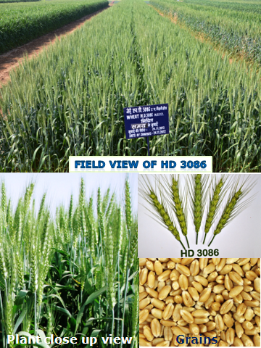
Index

SN | Item | Page no.
1 | Summary of Proposal | 1
2 | Proforma | 2
3 | Summary Yield Data of Coordinated Varietal Trials | 7
4 | Adaptability to Agronomic Variables | 11
5 | Reaction to Major Diseases | 13
6 | Reaction to Insect Pests | 16
7 | Data on Quality Characteristics | 17
8 | Data on Other Important Characters | 21
9. | Parentage and pedigree | Annexure I,II
10. | DNA profile of variety | Annexure III,IV
11. | Descriptors of variety | Annexure V
12. | Package of practice | Annexure-VI
13. | Copy of recommendation of workshop | Annexure-VII
14. | Copy of allotment of IC numbers from NBPGR | Annexure-VIII

1
Summary of Proposal (in bullets only)

- The proposed variety HD 3086 has given higher yield ranging from 0.52 to 4.19 % in three years of testing against the checks and qualifying variety DBW 88. The variety has shown a genetic potential of 71.1 q/ha

- The proposed variety HD 3086 has shown a very high level of resistance against stripe rust and leaf rust with slow rusting type of APR reactions compared to the checks and qualifying varieties which have shown susceptible reaction in both field and artificial conditions.

- The proposed variety HD 3086 is an Indian bred non 1B/1R material, will add to diversity in varietal pattern of NWPZ as two of the varieties namely PBW 621-50, HD 3059 already notified for cultivation as well and the qualifying variety DBW 88 has the common parentage originating from CIMMYT nurseries.

- In 55 trials, the proposed variety HD 3086 has appeared 24 times in the first non-significant group as compared to the check varieties DBW 17 (14/55), DPW 621-50 (20/45), HD 2967(10/21), & WH 1105 (10/21). It has shown very consistent performance over the years and locations. The variety has shown highest number of ear heads/m² and thousand kernel weight in agronomic trials.

- The proposed variety HD 3086 shown a very high degree of resistance against loose smut and Flag smut as compared to all the checks and qualifying varieties

- It has the best HMW sub-units combination for bread making with Glu-1 score, 10/10. The proposed variety has the best grain appearance score, hectoliter weight higher value of bread loaf volume (cc), bread quality score. The variety therefore, may find favour with bread making industries.

- The proposed variety has highest extraction rate (70.5), chapatti score (7.65) and wet gluten percent (31.3) and therefore it may also find favour with the milling and baking industries.

2

Proforma for Submission of Proposal for Release of Wheat Variety HD 3086 (Pusa Gautami) to Central Sub-Committee on Crop Standards Notification and Release of Varieties
1 | Name of the crop and species | : | Wheat, Triticum aestivum L.
2 | a) Name of the variety under which tested in AICRP trials | : | HD 3086
 | b) Proposed name of the variety | : | Pusa Gautami
3 | Sponsored by (institute) | : | Indian Agricultural Research Institute,  New Delhi-110012
4 | a) Institution or agency responsible for developing variety (with full address) | : | Division of Genetics, Indian Agricultural Research Institute, New Delhi-110012
 | b) Name of the person who helped in the development of the variety  Developers  Collaborators | : | Individuals listed by order of contribution as decided by the Programme/Institutional Leadership
5 | a) Parentage (with details of its pedigree including source from which variety/Inbred/ A, B and R lines of hybrid has been developed) | : | DBW 14/HD 2733//HUW 468  (Annexure-I, II)
 | b) Source of material in case of introduction | : | NA
 | c) DNA profile of variety/hybrid/inbred/A, B, R line of hybrid vis-à-vis check variety/ line |  | (Annexure-III,VI)
 | d) Breeding method used | : | Modified Pedigree Bulk Method
 | e) Breeding objective | : | Breeding wheat varieties with stripe and leaf rust resistance and higher productivity under timely sown conditions of North Western Plains Zone
6 | State the varieties which are most closely resemble the proposed variety in general characters | : | HD 3086 falls in the height group of HD 2329, HD 2687 and PBW 343. It resembles with HD 2329, HD 2687 and PBW 343 for ear waxiness and with HD 2329 and PBW 343 in grain shape
7 | Recommended productions ecology (Rainfed/Irrigated; high/low fertility; season) | : | Irrigated, timely sown conditions

3
8 | Specific area of its adaptation (zones and states for which variety is proposed) and recommended productions ecology | : | North Western Plains Zone [Punjab, Haryana, Delhi, Rajasthan (Except Kota and Udaipur Divisions), Western UP (Except Jhansi Division), Parts of J & K (Kathua district), parts of HP (Una district & Paonta Valley) and Uttrakhand (Tarai region)]
9 | Description of hybrid/variety | :
 | a) Plant height | : | 98 cms (Range:72-112)  (Table 6)
 | b) Distinguishing morphological characters | : | (Annexure-V)
 | c) Maturity (range in number of days) (from seedling/ transplanting to flowering, seed to seed) | : | Seed to Seed:  143 days (127-160)  (Table 6)
 | d) Maturity group (early, medium and late wherever such classification exists) | : | Medium Late  (Table 6)
 | e) Reaction to major diseases under field and controlled conditions (reaction to physiological strains/ races/pathotypes/ bio-types to be indicated wherever possible ) | : | HD 3086 has adult plant resistance to brown rust and yellow. It has also shown high degree of resistance to other diseases. (Table 3, 3.1 and 3.2)
 | f) Reaction to major pests (under field and controlled condition including store pests) | : | No major insect pests are reported in HD 3086
 | g) Agronomic features (e.g. resistance to lodging, shattering, fertilizer responsiveness, suitability to early or late sown conditions, seed rate etc.) | : | HD 3086 has shown superior performance under timely, late and very late sown conditions of north western plains zone comprising of Punjab, Haryana, Delhi, Rajasthan (Except Kota and Udaipur Divisions), Western UP (Except Jhansi Division), Parts of J& K (Kathua district), parts of HP (Una district & Paonta Valley) and Uttrakhand (Tarai region) with very low reductions in grain yield and other agronomic parameters. (Table 2 and 2.1)
 | h) Quality of produce | :
 | Grain quality | : | This variety has amber colour grain with a very good score of grain hardness, appearance, high protein content, and hectoliter weight and sedimentation value. It has also very good chapatti and excellent bread making qualities. (Table 5, 5.1, 5.2 & 5.3)
 | Fodder quality | : | --

4

 | i) Reaction to stresses | : | HD 3086 has shown tolerance to terminal heat stress. This is indicated by the performance of the variety under timely, late and very late sown conditions in yield and other agronomic parameters under the above two conditions. It is also highly resistant to yellow and brown rust and other diseases.
10 | Description of the parents of the hybrid | : | A line/Inbred 1 | B line/Inbred 2 | R line
 | a) Plant height (cm) | : | Not applicable
 | b) Distinguishing morphological characters | :
 | c) Days to flowering | :
 | d) Days to maturity (range in number of days – from seed to seed ) | :
 | e) Is there any problem of synchronization? If yes, method to overcome it | :
 | f) Reaction to major diseases (under field and controlled conditions, reaction to physiological strains/ races/bio-types/ pathotypes to be indicated wherever possible) | :
 | g) Reaction to major pests (under field and controlled conditions including store pests) | :
 | h) Agronomic features (e.g. resistance to lodging, shattering, fertilizer responsiveness, suitability to early or late sown conditions, seed rate etc.) | :
 | i) Reaction to stresses | :
11 | a) Yield data in coordinated trials (breeding, agronomy, pathology, entomology, quality etc) regional/inter regional district trials year wise (levels of fertilizer application, density of plant population and superiority over local control/standard variety to be indicated (to be attached) | : | Table 1, 1.1, 1.2, 1.3 (Breeding), Table 2, 2.1 (Agronomy), Table 3, 3.1, 3.2 (Pathology), Table 5, 5.1, 5.2, 5.3 & 5.4 (Quality), Table 6 (Ancillary data)

5

 | b) Yield data from national, demonstration/large scale demonstrations, if available (to be attached) | : | NA
12 | a) Agency responsible for maintaining breeder seed | : | Indian Agricultural Research Institute  New Delhi-110012
 | b) Quantity of breeder seed in stock (kg)  Variety  A line  B line  R line  Hybrid | : | 15 quintals of breeder seed is available to meet all the requirements of the seed chain
13 | Specific recommendations, if any, for seed production (e.g. staggered sowing, plating ratio of parental lines of hybrids in foundation and certified seed production, probable area of seed production) | : | Standard wheat crop protocols (Indian Minimum Seed Certification Standards)
14 | Vivid presentation (field view, close-up of single plant and seed/economic parts) |  | Attached
15 | a) Whether recommended by any workshop, seminar, conference, state seed committee etc. | : | Yes, the variety HD 3086 has been identified in the 52nd Wheat Researchers Meeting held at CSAUA&T, Kanpur during 1-4 September, 2013. (Annexure-VI)
 | b) If so, its recommendations with specific justifications for the release of proposed variety | : | The recommendations were as follows:  “Both varieties were considered simultaneously and identified based on better SRT of DBW 88 and low ACI of HD 3086 for stripe rust”.
16 | Specific area of its adaptation |  | Irrigated, timely sown conditions of Punjab, Haryana, Delhi, Rajasthan (Except Kota and Udaipur Divisions), Western UP (Except Jhansi Division), Parts of J & K (Kathua district), parts of HP (Una district & Paonta Valley) and Uttrakhand (Tarai region)
17 | Acknowledgement of submission of seed sample of variety/hybrid/inbred/ A, B and R lines of hybrid from NBPGR and IC numbers | : | IC No. 598202 dated 05.09.2013  (Annexure-VII)
18 | Package of practices along with attainable yield levels |  | (Annexure-VIII)

6

19 | Information on acceptability of the variety by farmers/ consumers/ industry, if available | : | Nil
20 | Any other pertinent information | : | HD 3086, therefore, is a total balance of traits that makes a variety more profitable for farmers. It has high yield potential, better disease resistance, amenable to different sowing situations thereby indicating heat tolerance, high grain weight and appropriate industrial applications. These qualities will optimize the investment, yield for maximum return and gives maximum economic return to the farmers of NWPZ comprising of Punjab, Haryana, Delhi, Rajasthan (Except Kota and Udaipur Divisions), Western UP (Except Jhansi Division), Parts of J & K (Kathua district), parts of HP (Una district & Paonta Valley) and Uttrakhand (Tarai region)”.

Signature of all contributors

-sd-
Signature of Head of institution
(Seal)
Checklist for proforma for submission of proposal for release of crop - variety to central sub-committee on crop standards notification and release of varieties

Details/document | Attached
Parentage with details of its pedigree including source from which variety/Inbred/A, B and R lines of hybrid has been developed | Yes | No
Source of material in case of introduction (IC/EC numbers provided by NBPGR) | Yes | No
Flow chart of details of development of variety/ parental lines of hybrids | Yes | No
Molecular/ DNA profile of variety/hybrid/A, B, R line of hybrid vis-à-vis check variety/ line (details of unique amplicons that distinguishing markers along with photographs | Yes | No
Detailed description of hybrid/variety | Yes | No
Detailed description of the parental lines of hybrid | Yes | No
Yield data and other data on diseases, insect-pest, quality etc. from coordinated trials | Yes | No
Yield data from national, demonstration/large scale demonstrations | Yes | No
Specific recommendations, if any, for seed production (e.g. staggered sowing, plating ratio of parental lines of hybrids in foundation and certified seed production, probable area of seed production etc.) | Yes | No
Vivid presentation (field view, close-up of single plant and seed) with the help of photographs of the variety | Yes | No
Recommendation of workshop, conference | Yes | No
Acknowledgement of submission of seed sample of variety/hybrid/ A, B and R lines of hybrid submitted to NBPGR | Yes | No
Package of practices | Yes | No
Proforma signed by all co-authors and Head of Organization | Yes | No
Any other pertinent information | Yes | No

Signature of Head of Institution

7
 |  |  | Table 1: Summarized yield data of coordinated trials
Name of the proposed variety: HD3086 |  |  |  |  |  | Adaptability Zone: North Western Plains Zone
 |  |  |  |  |  | Production condition: Irrigated, Timely Sown
Item | Year of testing | No. of trials | Proposed Variety HD 3086 | Checks |  |  |  | Qualifying variety | C. D.
 |  |  |  | DBW17 | DPW621-50 | HD2967 | WH 1105 | DBW88
Mean Yield q/ha | 2010-11 | 10 | 53.8 | 50.0* | - | - | -- | 52.8 | 2.7
 | 2011-12 | 24 | 56.6 | 54.7* | 55.4* | - | 55.5 | 56.1 | 0.9
 | 2012-13 | 22 | 52.6 | 50.6* | 53.0 | 53.3 | 53.9 | 52.9 | 1.0
 | Mean | -- | 54.33 | 51.77 | 54.2 | 53.3 | 54.70 | 53.93
 | Weighted Mean | -- | 54.56 | 52.28 | 54.28 | 53.30 | 54.75 | 54.28 | --
``% Increase over check varieties | 2010-11 | 10 | -- | 7.06 | - | - | 4.46 | 1.86 | --
 | 2011-12 | 24 | -- | 3.36 | 2.12 | - | 1.94 | 0.88 | --
 | 2012-13 | 22 | -- | 3.80 | -0.76 | -1.33 | -2.47 | -0.57 | --
 | Weighted Mean | -- | -- | 4.19 | 0.52 | 2.32 | -0.35 | 0.52 | --
Yield Potential (Q/ha) | 2010-11 | -- | 63.6 | 57.7 | -- | -- | -- | 65.2 | --
 | 2011-12 | -- | 71.1 | 71.1 | 71.7 | -- | -- | 69.9 | --
 | 2012-13 | -- | 65.4 | 69.6 | 66.8 | 72.7 | 75.6 | 67.2 | --
 | Mean | -- | 66.7 | 66.1 | 68.9 | -- | -- | 67.4 | --
Frequency in top NS group | 2010-11 | 10 | 4/10 | 0/10 | - | - | 11/26 | 5/10 | --
 | 2011-12 | 24 | 13/24 | 8/24 | 13/24 | - | 9/24 | 13/24 | --
 | 2012-13 | 22 | 7/21 | 6/21 | 7/21 | 10/21 | 10/21 | 8/21 | --
 | Total | 55 | 24/55 | 14/55 | 20/45 | 10/21 | 10/21 | 26/55 | --
*Significantly superior

8
Table 1.1: Yield data (q/h) of coordinated trials at individual locations in NIVT during 2010-11
Name of the proposed variety: HD3086 Adaptability Zone: North Western Plains Zone
Production condition: Irrigated, Timely Sown
Trial/Year/ Location | Proposed Variety HD 3086 | Checks |  |  |  | Qualifying variety | CD
 |  | DBW17 | DPW621-50 | HD2967 | WH1105 | DBW88
DELHI | 55.4(2)* | 46.2(21) | - | - | - | 4402(29) | 5.8
HISAR | 62.7(3)* | 57.7(14) | - | - | - | 63.0(2)* | 6.0
KAUL | 50.0(17) | 47.8(22) | - | - | - | 56.5(4)* | 6.7
KARNAL | 52.8(18) | 55.6(14) | - | - | - | 59.6(4)* | 3.4
GURDASPUR | 54.8(4)* | 45.7(34) | - | - | - | 53.9(5)* | 4.9
LUDHIANA | 63.6(6)* | 51.4(26) | - | - | - | 65.2(3)* | 9.2
DURGAPURA | 49.4(18) | 48.0(24) | - | - | - | 47.1(26) | 5.2
TABIJI | 52.1(12) | 43.9(32) | - | - | - | 38.5(45) | 5.2
PANTNAGAR | 52.5(22) | 54.2(19) | - | - | - | 61.3(3) | 7.4
MODIPURAM | 45.0(22) | 49.4(10) | - | - | - | 38.9(42) | 5.7
*In the first group of mean performance with non-significant differences
9
Table 1.2: Yield data (q/h) of coordinated trials at individual locations in AVT I during 2011-12
Trial/Year/ Location | Proposed Variety HD 3086 | Checks |  |  |  | Qualifying variety | CD
 |  | DBW17 | DPW621-50 | HD2967 | WH1105 | DBW88
DELHI | 60.2(7) | 66.4(2)* | 63.5(5)* | - | 67.2(1)* | 62.8(6)* | 5.4
BAWAL | 65.7(1)* | 54.7(7) | 51.0(11) | - | 59.0(3) | 51.2(10) | 4.5
KARNAL | 63.9(5) | 60.5(9) | 60.8(7) | - | 65.3(2)* | 65.2(3)* | 1.3
FARIDABAD | 59.5(1)* | 52.8(5) | 45.6(10) | - | 45.1(11) | 54.4(3) | 1.2
HISAR | 56.5(3)* | 55.7(6)* | 53.2(7)* | - | 49.2(11) | 49.4(10) | 4.3
KAUL | 63.2(1)* | 53.1(9) | 59.1(4)* | - | 61.6(2)* | 57.8(6) | 4.3
SHIKOHPUR | 71.1(3)* | 71.1(4)* | 68.2(10) | - | 71.6(1)* | 69.9(8)* | 2.7
UCHANI | 52.5(4)* | 56.0(1)* | 54.7(2)* | - | 50.0(8) | 50.5(6) | 4.9
DHAULAKUAN | 45.6(4) | 42.2(7) | 41.1(11) | - | 41.1(10) | 46.5(3)* | 4.0
CHATHA | 45.3(1)* | 40.8(8) | 39.3(11) | - | 40.8(8) | 44.3(2)* | 2.1
BATHINDA | 59.9(9) | 65.0(7)* | 67.1(2)* | - | 62.14(8)* | 66.8(4)* | 6.0
GURDASPUR | 62.3(1)* | 51.4(12) | 62.3(1)* | - | 60.9(5)* | 58.5(7) | 3.7
KAPURTHALA | 54.9(9) | 54.9(10) | 59.7(1)* | - | 53.7(11) | 56.7(3) | 2.9
LUDHIANA | 60.9(8) | 54.7(11) | 71.7(1)* | - | 66.2(5) | 68.1(4)* | 5.0
RAUNI | 63.9(8) | 64.9(6) | 70.7(1)* | - | 64.1(7) | 69.1(2)* | 5.1
ALWAR | 44.8(11) | 50.3(4) | 48.6(7) | - | 54.1(3)* | 55.8(2)* | 7.0
DURGAPURA | 53.6(7) | 57.8(3)* | 56.7(5)* | - | 59.6(1)* | 58.6(2)* | 3.5
S. G. NAGAR | 44.7(9) | 47.9(4) | 49.2(2)* | - | 47.8(5) | 44.6(10) | 2.7
BAREILLY | 58.7(3)* | 57.6(4)* | 56.5(6)* | - | 59.2(2)* | 60.1(1)* | 4.2
BULANDSHAHR | 60.5(9) | 61.2(8) | 54.9(13) | - | 61.7(6) | 64.7(2)* | 3.2
MODIPURAM | 56.6(2)* | 56.8(1)* | 52.1(10) | - | 54.4(7) | 54.5(6) | 2.1
NAGINA | 52.0(1)* | 44.6(10) | 45.6(7) | - | 46.0(5) | 45.1(9) | 1.9
UJHANI | 47.2(3)* | 40.8(7) | 48.5(1)* | - | 38.8(8) | 35.8(10) | 2.4
PANTNAGAR | 55.4(2)* | 52.8(6) | 50.2(9) | - | 52.6(7) | 55.1(3)* | 2.9

10
Table 1.3: Yield data (q/h) of coordinated trials at individual locations in AVT II during 2012-13

Trial/Year/ Location | Proposed Variety HD 3086 | Checks |  |  |  | Qualifying variety | CD
 |  | DBW17 | DPW621-50 | HD2967 | WH1105 | DBW88
DELHI | 62.9(2)* | 60.5(6)* | 55.2(14) | 62.7(3)* | 59.6(7)* | 57.6(12)* | 5.4
HISAR | 42.0(8) | 47.9(2) | 39.7(17) | 40.8(14) | 52.9(1)* | 41.1(12) | 4.1
BAWAL | 55.8(9)* | 52.4(12) | 50.9(14) | 57.2(7)* | 60.0(1)* | 58.1(6)* | 5.9
FARIDABAD | 38.0(13) | 40.5(10) | 46.8(1)* | 46.0(3)* | 40.0(12) | 42.3(8) | 0.8
DWR-KARNAL | 47.6(10) | 50.8(6) | 48.6(9) | 51.3(4) | 51.4(2) | 51.4(3) | 1.4
SHIKOHPUR | 60.3(3)* | 50.7(15) | 60.1(4)* | 54.5(11) | 52.4(13) | 54.4(12) | 4.3
CHATHA | 42.1(6) | 39.1(13) | 44.5(3)* | 41.5(9) | 37.5(14) | 44.6(2)* | 1.8
LUDHIANA | 68.3(6) | 62.1(12) | 64.8(11) | 72.7(3)* | 75.6(2)* | 57.8(13) | 6.2
BATHINDA | 47.2(16) | 55.7(2)* | 52.5(11)* | 53.8(7)* | 50.3(13) | 55.9(1)* | 4.7
GURDASPUR | 48.2(9) | 34.7(17) | 53.1(7) | 57.2(3) | 58.1(2) | 50.6(8) | 2.6
KAPURTHALA | 50.1(16) | 52.8(14) | 52.0(15) | 54.7(11) | 60.6(1)* | 58.4(3) | 2.0
RAUNI | 55.5(8)* | 55.2(10)* | 57.1(5)* | 56.5(6)* | 57.5(3)* | 56.3(7)* | 3.3
DURGAPURA | 54.6(12) | 56.6(9)* | 55.2(11) | 57.1(7)* | 60.1(3)* | 60.6(2)* | 6.1
TABIJI | 43.9(11) | 41.3(16) | 47.6(8) | 53.3(2)* | 53.9(1)* | 43.3(12) | 2.1
ALWAR | 55.0(4)* | 47.6(12) | 51.1(7) | 46.2(13) | 49.3(11) | 42.3(17) | 7.6
S. G. NAGAR | 59.8(11) | 63.6(2)* | 61.8(4) | 63.2(3)* | 57.5(14) | 61.0(5) | 2.4
BAREILLY | 49.6(5) | 50.2(3) | 47.1(12) | 48.5(9) | 47.4(11) | 49.4(8) | 3.8
MODIPURAM | 66.0(9) | 69.6(1)* | 66.8(6) | 68.6(2)* | 56.8(17) | 67.2(5) | 2.1
UJHANI | 41.6(9) | 36.7(15) | 48.4(1)* | 41.1(10) | 35.2(17) | 45.4(4)* | 3.9
BULANDSHAHR | 65.7(3)* | 49.7(13) | 60.1(10) | 49.3(14) | 65.4(4)* | 66.6(2)* | 5.8
PANTNAGAR | 49.9(3)* | 45.7(9) | 48.7(5)* | 42.9(13) | 51.0(2)* | 47.8(6) | 2.8

11

Table 2: Adaptability to Agronomic Variables (2012-13)
Name of the proposed variety: HD3086 |  |  |  |  |  |  |  |  |  |  |  |  |  |  |  | Adaptability Zone: North Western Plains Zone
 |  |  |  |  |  |  |  |  |  |  |  |  |  |  |  | Production condition: Irrigated, Timely Sown
Nature of Expteriment | Experiment/ Item |  | Agronomic Conditions |  | Proposed variety HD 3086 |  |  |  | Checks |  |  |  |  |  |  |  |  |  |  |  |  |  | Qualifying variety
 |  |  |  |  |  |  |  |  | DBW17 |  |  |  | DPW621-50 |  |  |  | HD2967 |  | PBW550 |  | WH1105 |  | DBW88
 |  |  |  |  | Yld |  | Rk |  | Yld |  | Rk |  | Yld |  | Rk |  | Yld | Rk | Yld | Rk | Yld | Rk | Yld |  | Rk
Date of Sowing Experiment | YIELD (Q/HA) |  | TIMELY SOWN |  | 53.54 |  | 4 |  | 55.06 |  | 1 |  | 53.33 |  | 6 |  | 51.88 | 7 | 54.33 | 2 | 53.43 | 5 | 54.32 |  | 3
 |  |  | LATE SOWN |  | 43.54 |  | 4 |  | 44.83 |  | 1 |  | 44.28 |  | 3 |  | 42.36 | 6 | 42.55 | 5 | 42.06 | 7 | 44.69 |  | 2
 |  |  | MEAN |  | 48.54 |  | 4 |  | 49.94 |  | 1 |  | 48.80 |  | 3 |  | 47.12 | 7 | 48.44 | 5 | 47.75 | 6 | 49.51 |  | 2
 | Yield (q/ha) under recommended sowing date |  |  |  | 53.54 |  | 4 |  | 55.06 |  | 1 |  | 55.33 |  | 6 |  | 51.88 | 7 | 54.33 | 2 | 53.43 | 5 | 54.32 |  | 3
 | Percentage loss over recommended condition |  |  |  | -18.68 |  |  |  | -18.58 |  |  |  | -16.97 |  |  |  | -18.35 |  | -21.68 |  | -21.28 |  | -17.73
 | CD (P=0.05). SOWING(A) =0.52; VARIETY (B) = 1.28; (B within A) = NS; (A within B) = NS

Note: specify each date of sowing, fertilizer level and number of irrigations at i, ii, iii
12
Table 2.1: Data on ancillary characters under different sowing dates

 |  | (Agronomical trial 2012-13)
Name of the proposed variety: HD3086 |  |  | Adaptability Zone: North Western Plains Zone
 |  |  | Production condition: Irrigated, Timely Sown
Agronomic Conditions (Sowing date) | Proposed variety HD 3086 | Checks |  |  |  |  | Qualifying variety
 |  | DBW17 | DPW621-50 | HD2967 | PBW550 | WH1105 | DBW88
Ear-heads/m²
TIMELY SOWN | 472(1) | 457(2) | 438(4) | 430(5) | 427(6) | 407(7) | 442(3)
LATE SOWN | 405(1) | 394(3) | 394(2) | 384(4) | 372(5) | 355(7) | 364(6)
MEAN | 438(1) | 426(2) | 416(3) | 407(4) | 399(6) | 381(7) | 403(5)
CD (P=0.05). SOWING(A) =5.66; VARIETY (B) = 10.66; (B within A) = 15.07; (A within B) =15.06
Grains/Ear head
TIMELY SOWN | 28.48(7) | 32.44(4) | 32.98(3) | 30.69(6) | 33.72(2) | 34.63(1) | 31.79(5)
LATE SOWN | 30.65(7) | 33.02(3) | 32.50(5) | 32.86(4) | 32.10(6) | 34.73(2) | 35.02(1)
MEAN | 29.56(7) | 32.73(5) | 32.74(4) | 31.77(6) | 32.91(3) | 34.68(1) | 33.40(2)
CD (P=0.05). SOWING(A) =0.64; VARIETY (B) =1.20; (B within A) = 1.70; (A within B) =1.70
1000 Grain Weight (g)
TIMELY SOWN | 40.39(1) | 38.03(6) | 37.62(7) | 40.08(2) | 38.65(5) | 39.67(3) | 39.50(4)
LATE SOWN | 36.13(3) | 36.00(4) | 35.49(5) | 34.98(7) | 36.33(2) | 35.00(6) | 36.46(1)
MEAN | 38.26(1) | 37.01(6) | 36.55(7) | 37.53(3) | 37.49(4) | 37.34(5) | 37.98(2)
CD (P=0.05). SOWING(A) =0.50; VARIETY (B) = 0.62; (B within A) =0.88; (A within B) = 0.95
13
 |  |  |  |  | Table 3: Reaction to major diseases
Name of the proposed variety: HD3086 |  |  |  |  |  |  |  | Adaptability Zone: North Western Plains Zone
 |  |  |  |  |  |  |  | Production condition: Irrigated, Timely Sown

Disease name | Condition of screening | Years of testing | Proposed variety HD 3086 |  |  | Checks |  |  |  |  |  |  |  |  |  |  |  |  |  |  |  | Qualifying variety
 |  |  |  |  |  | DBW17 |  |  |  | DPW621-50 |  |  |  | HD2967 |  |  |  | WH1105 |  |  |  | DBW88
 |  |  | HS | ACI |  | HS | ACI |  |  | HS |  | ACI |  | HS |  | ACI |  | HS |  | ACI |  | HS |  | ACI
STRIPE RUST | Natural | 2010-11 | 20S | 5.30 | 60S |  |  | 31.60 |  | 50S | 11.00 |  | 30S |  | 10.00 |  | 20S |  | 4.40 |  | 10S |  | 3.00
 |  | 2011-12 | 20S | 5.12 | 60S |  |  | 22.50 |  | 10S | 5.20 |  | - |  | - |  | 10S |  | 1.92 |  | 20S |  | 4.37
 |  | 2012-13 | 20S | 5.00 | 60S |  |  | 16.40 |  | 20S | 5.60 |  | 20S |  | 5.00 |  | 10S |  | 2.50 |  | 60S |  | 10.00
 | Artificial | 2010-11 | 10S | 3.7 | 60S |  |  | 31.6 |  | 60S | 20.0 |  | 10S |  | 4.1 |  | 30MS |  | 4.1 |  | 40S* |  | 6.4
 |  | 2011-12 | 20S | 2.9 | 40S |  |  | 6.9 | 5S |  | 1.1 |  | - |  | - |  | 5S |  | 0.6 |  | 20S |  | 5.4
 |  | 2012-13 | 20S | 5.3 | 80S |  |  | 29.5 | 60S |  | 14 |  | 60S |  | 15.1 |  | 10S |  | 1.9 |  | 40S |  | 13.4
LEAF RUST | Natural | 2010-11 | 10S | 2.00 | 10S |  |  | 2.00 | TR |  | 0.05 |  | TR |  | 0.03 |  | TR |  | 0.03 |  | 10S |  | 2.00
 |  | 2011-12 | 10S | 3.00 | 10S |  |  | 2.62 | TR |  | 0.02 |  | - |  | - |  | 5S |  | 0.65 |  | 0 |  | 0.00
 |  | 2012-13 | 5S | 1.20 | 0 |  |  | 0.00 | 5S |  | 1.20 |  | 0 |  | 0.00 |  | 0 |  | 0.00 |  | 0 |  | 0.00
 | Artificial | 2010-11 | 10MS | 3.3 | 30MS |  |  | 10.7 | 10S |  | 2.1 |  | 5S |  | 2.2 |  | 30S |  | 5.2 |  | 20S |  | 7.3
 |  | 2011-12 | 10S | 4.6 | 40S |  |  | 14.4 | 0 |  | 0.0 |  | - |  | - |  | 10S |  | 2.4 |  | 20MR |  | 2
 |  | 2012-13 | 20S | 10.0 | 10S |  |  | 2.8 | 10MS |  | 1.6 |  | 20S |  | 5.0 |  | 10MS |  | 1.6 |  | 0.0 |  | 0

(Use standard notations and symbols as specified in the crop)
14
Table 3.1: Reaction to other diseases (All India PPSN data 2012-13)

Name of the proposed variety: HD3086 |  |  |  |  |  |  |  |  | Adaptability Zone: North Western Plains Zone
 |  |  |  |  |  |  |  |  | Production condition: Irrigated, Timely Sown
Disease | Screening Condition | Year | Proposed variety HD 3086 |  | Checks |  |  |  |  |  |  |  | Qualifying variety
 |  |  |  |  | DBW17 |  | DPW621-50 |  | HD2967 |  | WH1105 |  | DBW88
 |  |  | HS | AV | HS | AV | HS | AV | HS | AV | HS | AV | HS | AV
POWDERY MILDEW (0-9) | Artificial | 2012-13 | 5.0 | 2.1 | 8.0 | 4.7 | 8.0 | 4.0 | 5.0 | 2.4 | 5.0 | 3.0 | 5.0 | 2.4
LEAF BLIGHT (0-9dd) | Artificial | 2012-13 | 89 | 46 | 67 | 35 | 67 | 46 | 46 | 25 | 69 | 45 | 79 | 46
LOOSE SMUT (%) | Artificial | 2012-13 | 0.0 | 0.0 | 60.0 | 24.9 | 31.2 | 16.1 | - | - | 50.3 | 17.9 | 60.1 | 28.0
KARNAL BUNT (%) | Artificial | 2012-13 | 43.7 | 10.8 | 11.3 | 4.1 | 21.7 | 5.3 | 31.3 | 7.5 | 22.4 | 9.1 | 25.5 | 4.6
FHB  (0-5) | Artificial | 2012-13 | 4 |  | 4 |  | 4 |  | 4 |  | 4 |  | 3
FOOT ROT (%) | Artificial | 2012-13 | 10 |  | 15 |  | 0 |  | 10 |  | 10 |  | 35
FLAG SMUT (%) | Artificial | 2012-13 | 0.0 | 0.0 | 5.3 | 1.8 | 1.1 | 0.4 | 0.0 | 0.0 | 0.0 | 0.0 | 6.7 | 3.4

(Use standard notations and symbols as specified in the crop)

15
Table 3.2: APR response to rust pathotypes, AUPDC values
Name of the proposed variety: HD3086 |  |  |  |  |  |  |  |  |  |  | Adaptability Zone: North Western Plains Zone
 |  |  |  |  |  |  |  |  | Production condition: Irrigated, Timely Sown
Disease | Year | Pathotype/ Location |  |  |  | Proposed variety HD 3086 |  | Checks |  |  |  |  |  | QV  DBW88
 |  |  |  |  |  |  |  | DBW17 |  | DPW621-50 |  | HD2967 | WH1105
LEAF RUST | APR RESPONSE
 | 2011-12 | 77-5 |  | DELHI |  | 5MS |  | TR |  | TR |  | - | 0 | 0
 |  |  |  | LUDHIANA |  | 0 |  | 0 |  | 0 |  | - | 10MR | 0
 |  | 104-2 |  | DELHI |  | 20MR |  | TR |  | 0 |  | - | 0 | TR
 |  |  |  | LUDHIANA |  | 0 |  | 0 |  | 0 |  | - | TMR | 0
 | 2012-13 | 77-5 |  | DELHI |  | 0 |  | 10MR |  | tR |  | tR | 10MS | tR
 |  |  |  | LUDHIANA |  | 0 |  | 0 |  | 0 |  | 0 | 0 | 0
 |  | 104-2 |  | DELHI |  | 10MS |  | 0 |  | tR |  | 0 | tMR | 5MR
 |  |  |  | LUDHIANA |  | 0 |  | 0 |  | 0 |  | 0 | 0 | 0
 |  |  |  | POWARKHEDA |  | 0 |  | 15MS |  | 20MS |  | 10S | 15S | 0
 | AUDPC RANGE
 | 2011-12 | DWR KARNAL |  |  |  | 101-200 |  | 0 |  | 0 |  | - | 0 | 0
 |  | MAHABALESHWAR |  |  |  | 1-100 |  | 1-100 |  | 1-100 |  | - | 1-100 | 1-100
STRIPE RUST | APR RESPONSE
 | 2011-12 | 46S119 |  | DELHI |  | 20S |  | TR |  | 0 |  | - | 0 | 0
 |  |  |  | LUDHIANA |  | TS |  | 0 |  | 0 |  | - | 0 | 0
 |  | 78S84 |  | DELHI |  | 0 |  | 20MS |  | 0 |  | - | 20MR | 10MR
 |  |  |  | LUDHIANA |  | TS |  | 20S |  | 10S |  | - | 5MS | 5S
 | 2012-13 | 46S119 |  | DELHI |  | 20MR |  | 0 |  | 0 |  | 0 | 0 | 0
 |  |  |  | LUDHIANA |  | 0 |  | 60S |  | 40S |  | 5S | 0 | 20S
 |  | 78S84 |  | DELHI |  | 0 |  | 0 |  | 5MR |  | 0 | 0 | 0
 |  |  |  | LUDHIANA |  | 10S |  | 80S |  | 20S |  | 10S | 5S | 20S
 | AUDPC RANGE
 | 2011-12 | DWR KARNAL |  |  |  | 1-100 |  | 501-1000 |  | 0 |  | - | 0 | 0
GENE POSTULATION | Yellow rust |  |  |  |  | Yr2+ |  | Yr9+ |  | - |  | Yr2+ | Yr2+ | -
 | Leaf rust |  |  |  |  | Lr13+10+3+ |  | Lr26+23+ |  | - |  | Lr23+ | Lr13+ | Lr13+10+
 | Black rust |  |  |  |  | Sr2+7b+ |  | Sr2+31+ |  | -- |  | Sr8a+11+ | -- | Sr11+

16
Table 4. Reaction to Insect Pests (No major insect pests are reported in HD 3086)

Name of proposed variety/Hybrid:-------------- |  |  |  |  | Adaptability Zone ---------------------
 |  |  |  |  | Production condition-------------------
Insect name | Condition | Year | Proposed Variety | National Check 1 | Zonal Check 2 | Local check 3 | Latest release Check 4 | Qual. Var. 1 | Qual. Var. 2 | Qual. Var. 3
Pest 1 | Natural | 1st year
 |  | 2nd year
 |  | 3rd year
 | Artificial | 1st year
 |  | 2nd year
 |  | 3rd year
Pest 2 | Natural | 1st year
 |  | 2nd year
 |  | 3rd year
 | Artificial | 1st year
 |  | 2nd year
 |  | 3rd year
Pest 3 | Natural | 1st year
 |  | 2nd year
 |  | 3rd year
 | Artificial | 1st year
 |  | 2nd year
 |  | 3rd year

17
Table 5: Data on Quality Characteristics

 |  | Proposed Variety HD 3086 | Checks |  |  |  | Qualifying variety
Quality Characterist. | Year |  | DBW17 | DPW621-50 | HD2967 | WH1105 | DBW88
Protein (%) | 2010-11 | 12.3 | 13.0 | - | - | - | 13.8
 | 2011-12 | 12.6 | 13.6 | 13.5 | - | 12.5 | 13.2
 | 2012-13 | 13.8 | 13.8 | 14.2 | 13.5 | 14.1 | 14.4
 | Mean | 12.8 | 13.5 | 13.9 | 13.5 | 13.3 | 13.8
Grain appearance (max score 10) | 2010-11 | 6.5 | 6.8 | - | - | - | 6.5
 | 2011-12 | 6.2 | 5.6 | 5.9 | - | 5.6 | 6.0
 | 2012-13 | 6.0 | 5.8 | 5.8 | 6.0 | 5.9 | 5.6
 | Mean | 6.2 | 6.1 | 5.9 | 6.0 | 5.8 | 6.0
Hectoliter weight (kg/ha) | 2010-11 | 74.9 | 74.8 | - | - | - | 73.3
 | 2011-12 | 77.1 | 78.0 | 78.0 | - | 78.1 | 78.4
 | 2012-13 | 78.7 | 79.6 | 76.7 | 78.1 | 78.5 | 77.4
 | Mean | 76.9 | 77.5 | 77.4 | 78.1 | 78.3 | 76.4
Sedimentation value (ml) | 2010-11 | 37 | 31 | - | - | - | 40
 | 2011-12 | 49 | 42 | 52 | - | 53 | 52
 | 2012-13 | 48 | 38 | 50 | 47 | 52 | 49
 | Mean | 45 | 37 | 51 | 47 | 53 | 47
Note : Specify the parameters under first column
18
 |  | Table 5.1: Data on other quality characters
Name of the proposed variety: HD3086 |  |  |  | Adaptability Zone: North Western Plains Zone
 |  |  |  | Production condition: Irrigated, Timely Sown
MW Sub-units | Year of testing | Proposed variety HD 3086 | Checks |  |  |  | Qualifying variety
 |  |  | DBW17 | DPW621-50 | HD2967 | WH1105 | DBW88
GLU-D1 | 2012-13 | 5+10 | 5+10 | 5+10 | 5+10 | 5+10 | 5+10
GLU-A1 | 2012-13 | 1 | 2* | 2* | 2* | 2* | 2*
GLU-B1 | 2012-13 | 17+18 | 7 | 17+18 | 17+18 | 7 | 17+18
GLU-1 SCORE | 2012-13 | 10 | 8 | 10 | 10 | 8 | 10

19

 | Table 5.2: Data on other quality characters
Name of the proposed variety: HD3086 |  |  | Adaptability Zone: North Western Plains Zone
 |  |  | Production condition: Irrigated, Timely Sown
Chapati, bread and Biscuit quality (2012-13)
Character | Proposed variety HD 3086 | Checks |  |  |  | Qualifying variety
 |  | DBW17 | DPW621-50 | HD2967 | WH1105 | DBW88
Extraction rate (%) | 70.5 | 70.1 | 71.3 | 71.1 | 69.2 | 70.6
Grain Hardness Index | 83 | 78 | 87 | 76 | 73 | 84
Wet Gluten (%) | 31.3 | 29.8 | 29.3 | 30.5 | 29.3 | 31.1
Dry Gluten (%) | 10.6 | 10.6 | 11.1 | 10.5 | 11 | 11
Gluten Index | 67 | 50 | 76 | 60 | 72 | 70
Bread loaf volume (cc) | 565 | 563 | 567 | 567 | 569 | 565
Bread quality (max score 10) | 6.79 | 6.73 | 6.8 | 6.8 | 6.86 | 6.81
Chapati quality (max score 10) | 7.65 | 7.54 | 7.57 | 7.65 | 7.56 | 7.66
Biscuit Quality (Spread Factor) | 6.85 | 7.08 | 6.98 | 7.69 | 7.37 | 6.88
Phenol Test (Max. Score 10) | 6.7 | 6.4 | 7 | 5.9 | 6.9 | 6.7
Quality characters related to the concerned crop
20

 | Table 5.3: Data on other quality characters
Name of the proposed variety: HD3086 |  |  | Adaptability Zone: North Western Plains Zone
 |  |  | Production condition: Irrigated, Timely Sown
Nutritional quality (2012-13)
Character | Proposed variety HD 3086 | Checks |  |  |  | Qualifying variety
 |  | DBW17 | DPW621-50 | HD2967 | WH1105 | DBW88
Yellow Pigment (ppm) | 2.86 | 3.48 | 2.92 | 3.48 | 3.45 | 3.14
Fe (ppm) | 38.6 | 38.6 | 36.6 | 37.7 | 38.7 | 37.9
Zn (ppm) | 35.8 | 44 | 37.2 | 35.3 | 38.6 | 35.6
21

Table 6: Data on other important characters

Name of proposed variety: HD 3086 |  |  |  |  | Adaptability Zone NWPZ
Sr. No | Character | Year | Proposed Variety HD 3086 |  | Checks |  |  |  |  |  |  |  | Qualifying variety
 |  |  |  |  | DBW17 |  | DPW621-50 |  | HD2967 |  | WH1105 |  | DBW88
 |  |  | Range | Mean | Range | Mean | Range | Mean | Range | Mean | Range | Mean | Range | Mean
1. | Days to heading | 2010-11 | 88-108 | 99 | 84-111 | 102 | 81-119 | 103 | 84-119 | 103 | 79-119 | 102 | 91-113 | 103
 |  | 2011-12 | 85-120 | 102 | 94-125 | 106 | 90-124 | 105 | - | - | 86-122 | 102 | 91-123 | 104
 |  | 2012-13 | 84-108 | 96 | 80-110 | 99 | 91-109 | 100 | 81-110 | 100 | 85-108 | 98 | 81-109 | 99
 |  | Mean | -- | 99 | -- | 102 | -- | 103 | -- | 102 | -- | 101 |  | 102
2. | Days to maturity | 2010-11 | 128-157 | 143 | 125-156 | 142 | 128-167 | 148 | 126-158 | 147 | 126-158 | 145 | 126-159 | 144
 |  | 2011-12 | 127-160 | 144 | 132-159 | 146 | 135-164 | 147 | - | - | 129-161 | 143 | 131-163 | 145
 |  | 2012-13 | 127-158 | 141 | 122-157 | 142 | 129-161 | 144 | 123-162 | 143 | 124-160 | 142 | 122-161 | 142
 |  | Mean | -- | 143 | -- | 143 | -- | 146 | -- | 145 | -- | 143 | -- | 144
3. | Plant height (cm) | 2010-11 | 88-112 | 102 | 78-101 | 90 | 84-110 | 99 | 91-118 | 103 | 89-110 | 99 | 90-121 | 103
 |  | 2011-12 | 88-110 | 99 | 73-100 | 88 | 88-113 | 101 | - | - | 84-110 | 97 | 88-113 | 101
 |  | 2012-13 | 72-106 | 92 | 98-98 | 85 | 80-103 | 94 | 82-109 | 96 | 74-102 | 92 | 79-107 | 94
 |  | Mean | -- | 98 | -- | 88 | -- | 98 | -- | 100 | -- | 96 | -- | 99
4. | 1000 grain weight | 2010-11 | 40-45 | 42 | 32-42 | 39 | 35-44 | 38 | 37-54 | 41 | 35-44 | 39 | 37-47 | 40
 |  | 2011-12 | 31-44 | 38 | 28-50 | 38 | 29-46 | 38 | - | - | 31-54 | 40 | 28-51 | 38
 |  | 2012-13 | 34-41 | 37 | 21-41 | 36 | 31-42 | 36 | 29-43 | 39 | 31-42 | 36 | 33-45 | 37
 |  | Mean | -- | 39 | -- | 38 | -- | 37 | -- | 40 | -- | 38 | -- | 38

Annexure-I

Annexure-II
PEDIGREE DETAILS AND PEDIGREE TREE OF WHEAT VARIETY HD 3086 (PUSA GAUTAMI)

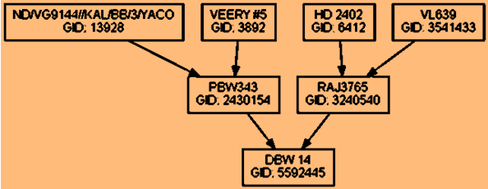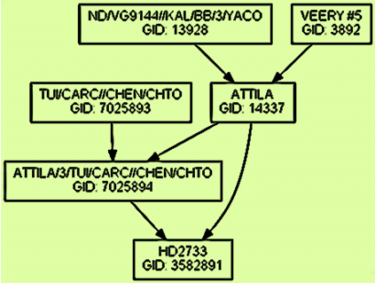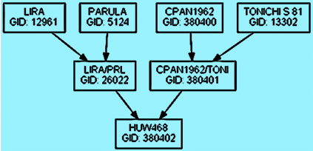

DBW 14/HD2733

HD 3086
(DBW 14/HD 2733//HUW 468)
Annexure-III
Marker assisted gene prospecting in Advanced Varietal Trial (Project Director Report, 2013)
Identification of DNA markers linked to traits of economic importance, their validation and utilization has become integral part of various crop improvement programmes. In an effort to harness the benefit of available markers, molecular biology programme of Directorate of Wheat Research, Karnal screened final year AVT 2012-13 test entries using various STS/AS-PCR markers for waxiness (Wx), leaf rust resistance (Lr), wheat-rye translocation (1B/1R), polyphenol activity (PPO), vernalisation (Vrn) etc. The allele distribution is shown in the table given below.
Profile of the AVT entries and checks using STS/AS-PCR markers
MARKERS | Vp1B3a | Vp1B3b | DuPw004a | DuPw004b | PPO18a | Wx-B1a | Wx-B1b | Wx-B1c | Lr10 | 1B/1R | Lr34
HS507 | - | + | + | + | - | + | + | + | + | + | -
HS536 | - | - | - | + | - | - | + | + | - | - | +
NIAW 1415 | - | + | + | - | - | + | + | - | - | - | -
HD2967 | - | + | + | - | + | + | + | - | - | - | -
HI8728 | - | - | + | - | - | - | + | + | + | - | NA
K1006 | + | - | - | + | + | + | + | - | - | - | -
PBW660 | + | - | + | - | - | + | + | - | - | + | -
WH1124 | + | - | + | - | - | + | + | - | - | - | -
DBW39 | + | - | + | + | - | + | + | + | - | + | +
DBW74 | + | - | + | - | + | + | + | + | - | - | -
DBW90 | + | + | + | + | + | + | + | - | - | - | -
DBW93 | + | - | + | - | - | + | + | + | - | - | -
DPW621-50 | + | - | + | + | + | + | + | + | + | - | +
GW322 | + | - | + | - | - | + | + | + | - | - | -
GW432 | - | + | - | + | - | + | + | + | - | - | NA
HD2932 | + | - | + | + | - | - | + | + | - | - | +
HD3070 | + | - | - | + | - | + | + | - | - | + | -
HD3076 | + | - | + | - | - | + | + | - | - | - | -
HD3091 | + | - | - | + | - | + | + | + | + | - | -
HI8498 | + | - | - | + | - | - | + | + | - | - | NA
HI8724 | + | - | - | + | + | - | + | + | - | - | NA
HI8725 | + | - | + | - | - | - | + | + | - | - | -
HI8727 | + | - | + | - | + | - | + | + | - | - | -
HI8731 | + | - | + | - | - | + | + | - | - | - | -
HS542 | - | - | - | + | - | + | + | + | - | - | +
HW5224 | - | - | - | + | - | + | + | - | - | - | NA
MACS6478 | + | - | + | - | - | + | + | + | - | - | -
MP3288 | - | + | + | - | - | + | + | - | - | - | -
NW5054 | + | - | + | - | + | + | + | + | - | - | -

Annexure III contd…

MARKERS | Vp1B3a | Vp1B3b | DuPw004a | DuPw004b | PPO18a | Wx-B1a | Wx-B1b | Wx-B1c | Lr10 | 1B/1R | Lr34
PBW661 | + | - | + | + | - | + | + | + | - | + | -
PBW674 | + | - | + | - | + | + | + | - | + | - | -
RAJ4250 | + | - | - | + | + | + | + | - | - | + | +
UAS334 | + | - | - | + | - | + | + | - | - | + | -
WH1098 | - | + | - | + | + | + | + | - | - | - | -
WH1120 | + | - | - | + | - | + | + | - | - | - | -
COW1 | + | - | - | + | + | + | + | + | - | - | +
DBW88 | + | + | + | - | + | + | + | + | - | - | -
HD3059 | + | - | - | + | + | + | + | + | + | - | -
HD3086 | - | + | + | - | - | - | + | + | - | - | -
HD3090 | + | - | + | + | - | + | + | + | - | + | -
HD3093 | + | - | - | + | - | + | + | - | - | - | -
HD3095 | + | - | + | - | - | + | + | - | + | - | -
HI1563 | + | - | + | + | - | + | + | + | - | - | +
MPO1255 | + | - | + | - | - | + | + | - | - | - | NA
PBW675 | - | + | - | + | + | + | + | - | - | - | -
WH1126 | + | - | - | + | - | + | + | + | - | - | -
WH1127 | + | - | + | - | - | + | + | - | - | - | NA

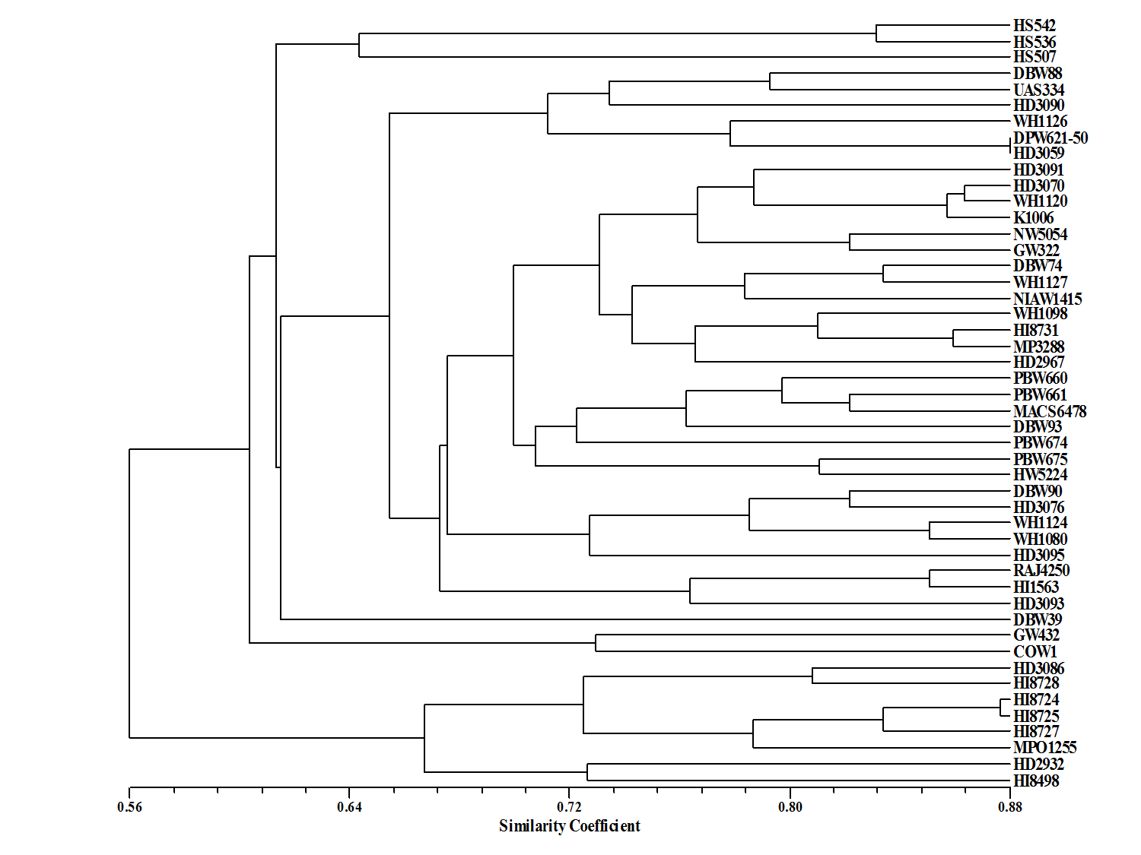
Annexure-IV

Annexure-V
HD 3086: Varietal Description
Area of adoption: NWPZ Production Conditions: Irrigated, Timely Sown
S. No. | Characteristics | Characteristics value of candidate variety HD 3086
1. | Coleoptile : Anthocyanin coloration | Absent
2. | Plant : growth habit | Semi Erect
3. | Foliage : colour | Green
4. | Flag leaf : Anthocyanin coloration of auricles | Absent
5. | Flag leaf : hairs on auricles | Moderate
6. | Plant : flag leaf attitude | Semi erect
7. | Time of ear emergence (50% flowering) | 99 Days (Range: 84-108)
8. | Flag Leaf: waxiness of sheath | Medium
9. | Flag leaf: waxiness of blade | Medium
10 | Ear: waxiness | Medium
11. | Culm: waxiness of neck (Peduncle) | Medium
12. | Flag leaf : length | Medium
13. | Flag leaf : width | Medium
14. | Plant : length (excluding awns/scurs) | 98 cms (Range:72-112)
15. | Ear : shape in profile | Parallel
16. | Ear : density | Dense
17. | Ear : length (excluding awns and scurs) | Short
18. | Awns or scurs: presence | Awns Present
19. | Scurs: | Absent
20. | Awns : length | Medium
21. | Awn : color | White
22. | Awn : attitude | Medium
23. | Outer glume : pubescence | Absent
24. | Ear: colour | White
25. | Lower glume: shoulder width (spikelets in mid-third of ear) | Narrow
26. | Lower glume: shoulder shape (as for 25) | Sloping
27. | Lower glume: beak length (as for 25) | Long
28. | Lower glume: beak shape (as for 25) | Straight
29. | Peduncle length | Medium
30. | Peduncle attitude (at the time of maturity) | Bent
31. | Grain: colouration with phenol | Light brown
32. | Grain: color | Amber
33. | Grain : shape | Oblong
34. | Grain : Germ width | Medium
35. | Brush hair : length | Medium
36. | Seed : size (weight of 1000 grains) | 39.0 (Range (31-45)
37. | Seasonal type | Spring
38. | Grain: Hardness | Hard

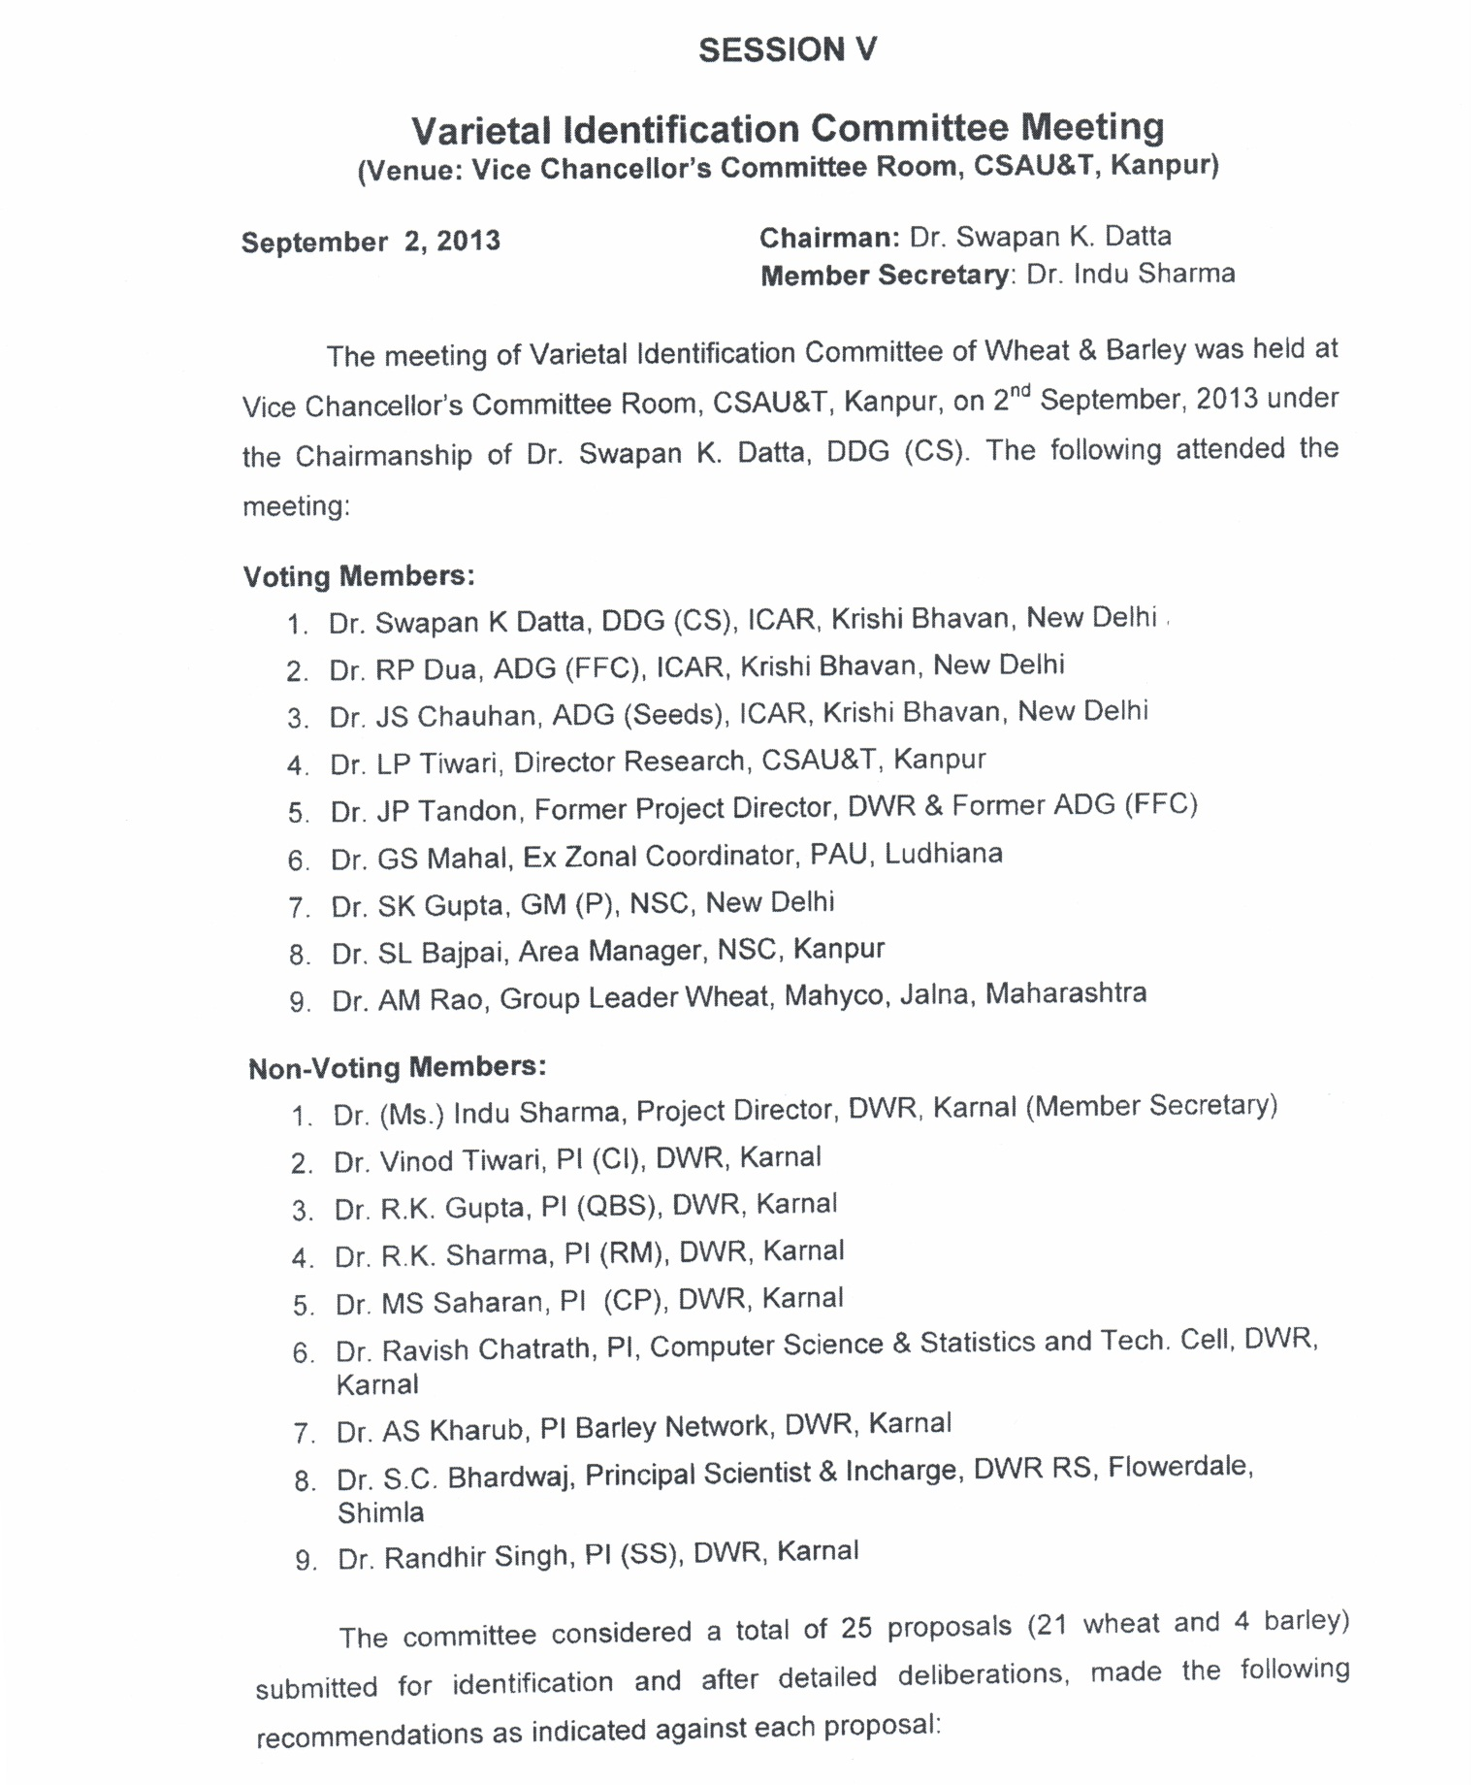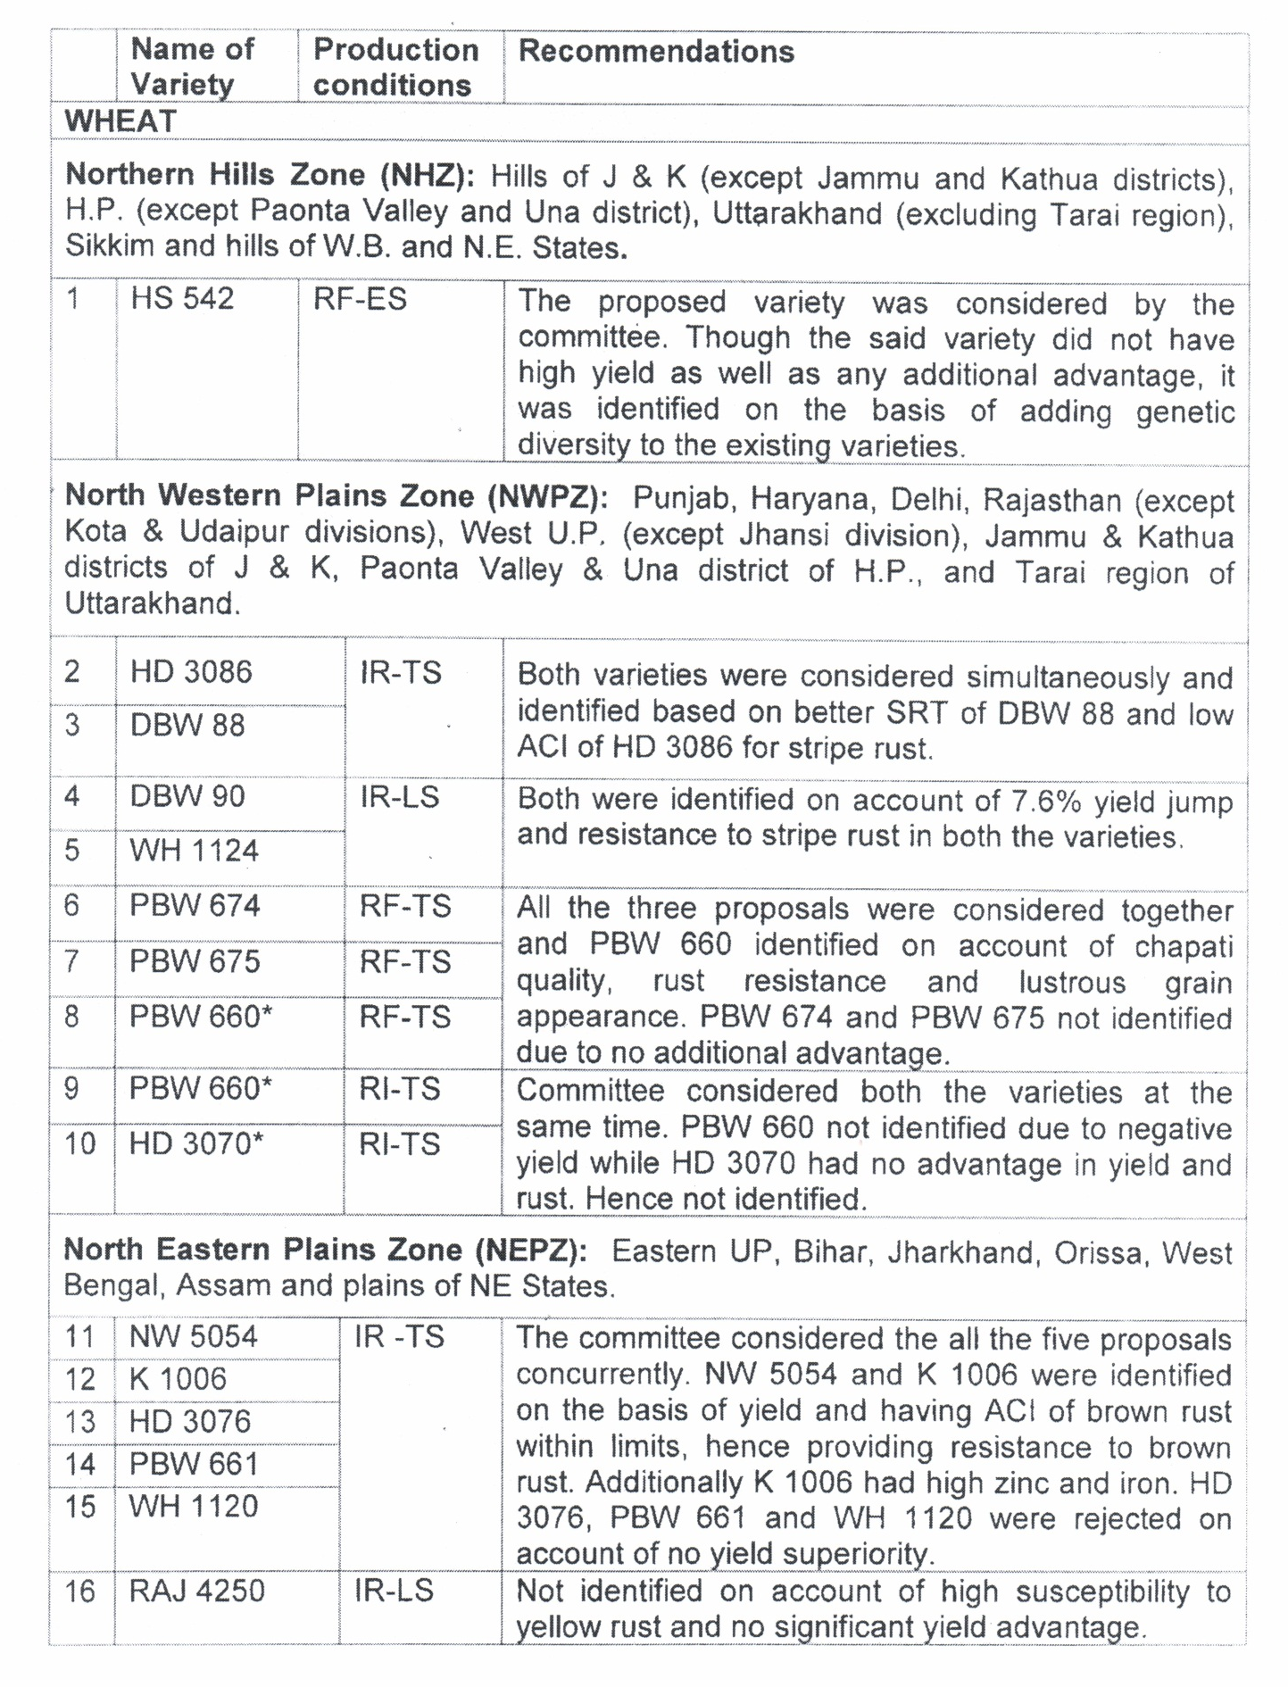
Annexure-VI
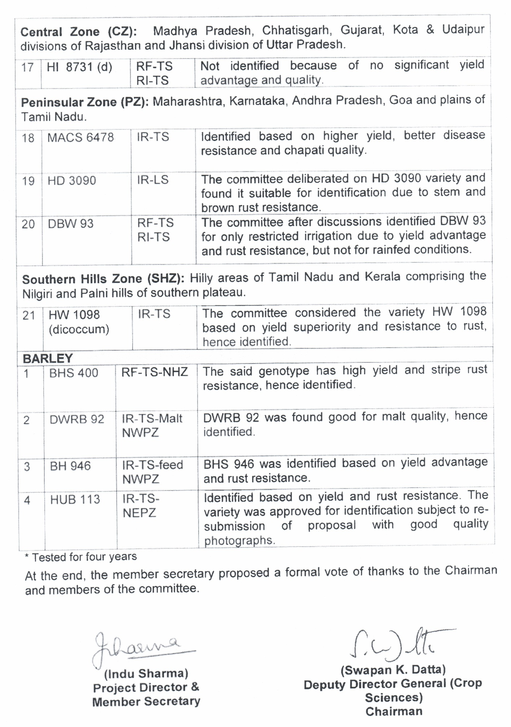
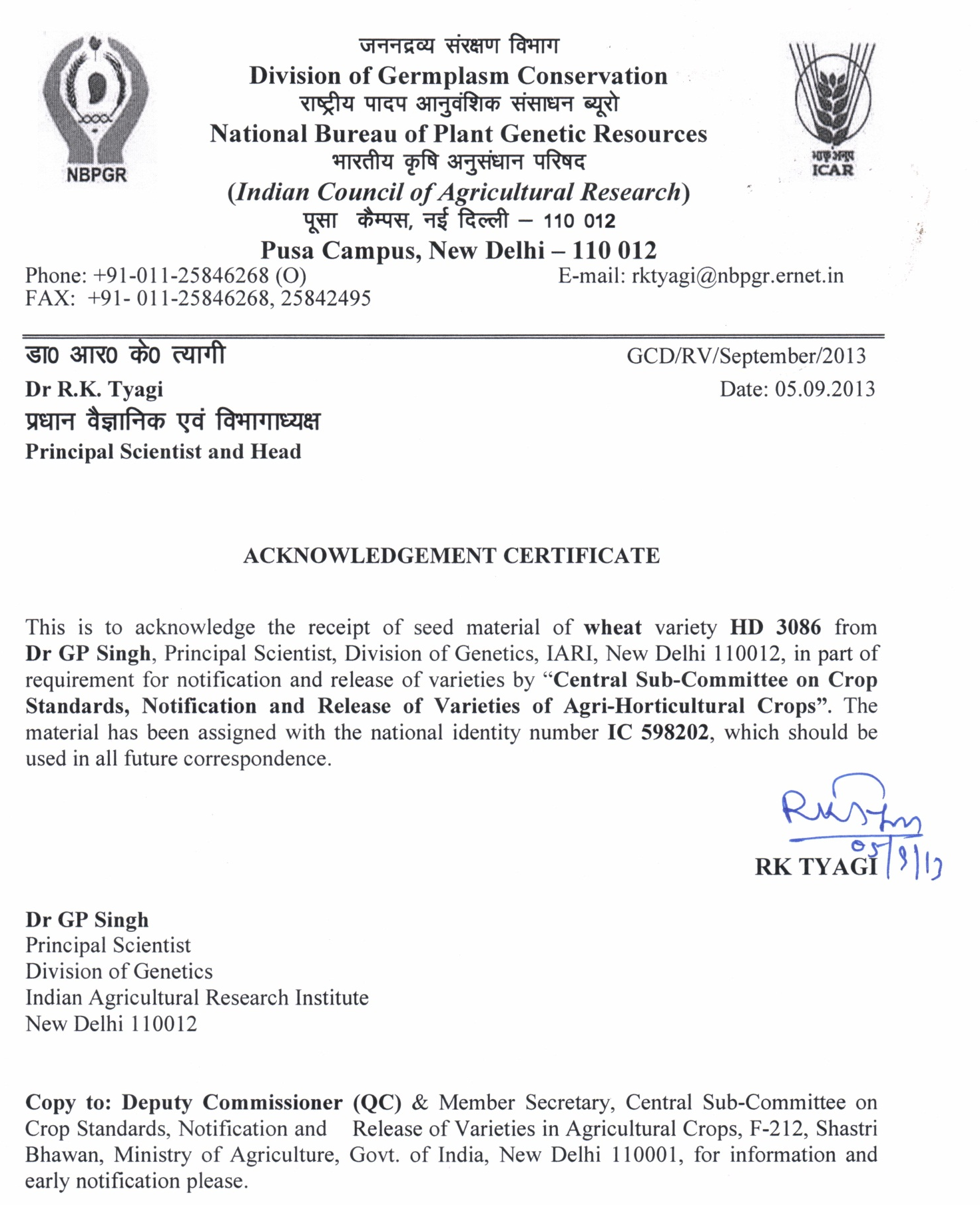
Annexure-VIII
Annexure-VII
Proforma for package of practices
Name of the crop: Bread wheat
Name of variety: HD 3086 (Pusa Gautami)

Sr. No. | Particulars |  | Details
1. | Suitability of the variety for the area (Recommended area for which variety has been released/ recommended) | : | Timely sown irrigated conditions of Punjab, Haryana, Delhi, Rajasthan (except Kota and Udaipur divisions), Western UP (except Jhansi division), parts of J&K (Jammu & Kathua districts), parts of HP (Una district & Paonta valley) and Uttrakhand (Tarai region).
2. | Selection of field/land preparation (Type of topography, soil condition, tillage operations for seed bed etc.) | : | Flat fertile soil, pre-sowing irrigation followed by ploughing with disc harrow, tiller and leveller at field capacity for optimum field conditions
3. | Seed Treatment (Recommended chemical with doses) | : | Vitavax @ 2.0 gm/kg seed
4. | Sowing Time (Optimum sowing period) | : | November 10-20
5. | Seed Rate/sowing method-line sowing with row to row and plant to plant distance | : | 100 kg/ha line sowing with row-to-row distance of 20cm and plant-to-plant 5 cm
6. | Fertilizer Doses & time of fertilizer’s application (Type and quantity of fertilizers) | : | 150:60:40 (N:P:K)  1/3 N at sowing and 2/3 at first node stage i.e. 35-40 DAS
7. | Weed Control (Name of weedicide(s) with dosages and timing of mechanical weeding, if any) | : | - For the control of broadleaved weeds 2,4-D at 500 g/ha or metsulfuron at 4 g/ha or carfentrazone at 20 g/ha can be sprayed using about 250 litres of water/ha.  - For the control of grasses isoproturon at 1000 g or clodinafop at 60 g or fenoxaprop 100g or sulfosulfuron at 25 g/ha should be used. In isoproturon resistant P. minor infested areas clodinafop or fenoxaprop or sulfosulfuron can be used.  - For the control of complex weed flora combination of isoproturon with 2,4-D or metsulfuron or sulfosulfuron with metsulfuron can be applied at 30-35 DAS at sufficient soil moisture
8. | Major disease and pest control (Type of Pest and disease with name of chemicals and dosages l& timing of application) | : | The variety is resistant to stripe & leaf rust and other diseases. However, for Stripe rust, leaf rust, Karnal bunt and powdery mildew, apply propiconazole/ triademefone/tebucanazole at 0.1% (1ml/litre) as foliar spray twice after disease appearance at 15 days interval
Contd…..

Annexure-VI Contd….
9. | Irrigation schedule (Critical stages for irrigation and method of irrigation) | : | 5-6 irrigations. First at 20-25 DAS and thereafter at 20d interval
10. | Harvesting (Approximate days of harvestable maturity) | : | 127-160 (average 143d)
11. | Quality characteristics of variety, if any (Prominent characteristics of variety) | : | It has the best HMW sub-units combination for bread making with Glu-1 score, 10/10 and high protein content. Parallel dense spike with amber oblong grains
12. | Expected yield of the variety per acre  from-—-qtls to qtls/acre (Yield  subject to use under area of adaption  and the recommended climatic  conditions and adoption of package  and practices | : | 21.52 q/acre to 22.64 q/acre (Average yield over three years of testing in Coordinated Trials. Genetic potential of the variety is 28.44 q/acre.
Note: These are standard package and practices which may vary with environmental fluctuations.

